MSC-E contribution to the joint CEIP/MSC-E technical report

EMISSION DATA FOR MODELING HEAVY METALS AND PERSISTENT ORGANIC POLLUTANTS

1. Introduction

Information on pollutant’s emission to the atmosphere and other environmental media is one of the key parameters required for model assessment of pollution levels and transboundary fluxes. Completeness and uncertainties of emission data can significantly affect quality of the model estimates. Sensitivity analysis of the modeling results has shown that, in many cases, emission uncertainties largely determine the overall uncertainty of the model assessment [Travnikov, 2000; Travnikov and Ilyin, 2005].
Application of chemical transport models for assessment of heavy metal (HMs) and persistent organic pollutant (POPs) pollution levels in the EMEP countries requires anthropogenic emission data spatially distributed (or ‘gridded’) over the regular EMEP grid. It should be noted that model reproduction of air concentration and deposition fluxes needs emission data covering the entire EMEP domain that includes not only territories of all EMEP countries but also adjacent areas (Northern Africa, Middle East etc.) Along with this, application of the gridded emission data for modeling requires evaluation of additional emission parameters. They comprise chemical composition of emitted pollutants, vertical distribution of emission height and temporal variation of anthropogenic emissions along the year. Since these emission characteristics are specific for different source categories, the gridded emission data should be split into different emission sectors.
Some HMs and POPs (e.g. Hg, PCDD/Fs, PCBs and HCB) are persistent in the environment and can travel over long distances. In many EMEP countries pollution levels of these substances are significantly influenced by emissions from other parts of the globe. Therefore, emission inventories on a global scale are required for pollution assessment within the EMEP region. Besides, cycling of HMs and POPs in the environment has a complex character and includes not only atmospheric transport and transformations but also bi-directional exchange with the earth’s surface. Natural and secondary emission sources should be taken into account when assessing both effectiveness of environment protection policy and human exposure of these contaminants.

Current situation
Emission data currently provided by the EMEP countries in their national inventories cover only part of the information that is required for model assessment of HM and POP pollution. The gap filling is performed by the Centre on Emission Inventories and Projections (CEIP) to provide complete sets of gridded emissions over the EMEP domain. The missing emission parameters for model application are prepared by the Meteorological Synthesizing Centre – East (MSC-E) (Table 1). Assumptions and methodologies used for evaluation of these parameters are discussed below along with characteristics of their major uncertainties.

Table 1. Information on HM and POP emissions officially provided by CEIP
Additional emission data required for model assessment of pollution levels
Information on HM (Pb, Cd, Hg) and  POP (PAHs, HCB, PCBs, PCDD/Fs) emissions | Official emission data (CEIP) | Emission data required for modeling
Time-series of national total emissions (annually) | X
Gridded sectoral emissions (once in five years) | X
Emissions of Large Point Sources (once in five years) | X
Gridded total emissions for the latest reported year generated by CEIP (except PCBs) (annually) | X
Time-series of gridded annual emissions 1990-2012 |  | X
Vertical distribution of emissions |  | X
Speciation of Hg forms (Hg˚, Hg(II)_{gas}, Hg(II)_{part}) |  | X
Congener composition for POPs  (PCDD/Fs – 17 congeners, PCB-153) |  | X
Temporal variation of emissions |  | X
Historical emissions of PCBs, HCB, PCDD/Fs up to 1990 |  | X
Emissions to other environmental compartments (PCDD/Fs, HCB) |  | X
Emissions for the non-EMEP countries within the EMEP domain. (North Africa and Middle East). |  | X
Natural emissions |  | X
Re-suspension, re-emissions |  | X
Global emission inventories (PCDD/Fs, HCB, PCBs, Hg) |  | X

Additional information on emission data for modeling including approaches of their preparation, methodologies used for gap filling, and discrepancies between officially reported and expert emission estimates is available in the Annexes.

2. Gridded annual emission data
Datasets of gridded emission data for HMs and POPs are prepared by CEIP based on official data reported by Parties to CLRTAP and complemented by expert estimates. In particular, CEIP annually (for the latest reported year) prepares gridded data for three primary heavy metals (Pb, Cd and Hg) and selected POPs (PCDD/Fs, PAHs, HCB, and PCBs) for different emission sectors (GNFR14). Gridded emissions reporting by Parties to CLRTAP are shown in Figure 1. Nowadays, the gridded data are available for the base year 1990 (only for B(a)P) and for the years of the period from 2009 to 2013. Starting from 2015 data on PAH emissions are prepared separately for different PAH compounds (B(a)P, B(b)F, B(k)F, IP). It should be noted that consistent time series of gridded emission data for the whole period from 1990 to 2013 (including the latest recalculations of all years of the period) are not available for modeling of long-term pollution trends.

Priority heavy metals (Pb, Cd, Hg) POPs (PCDsD/PCDFs, PAHs, HCB and PCBs)
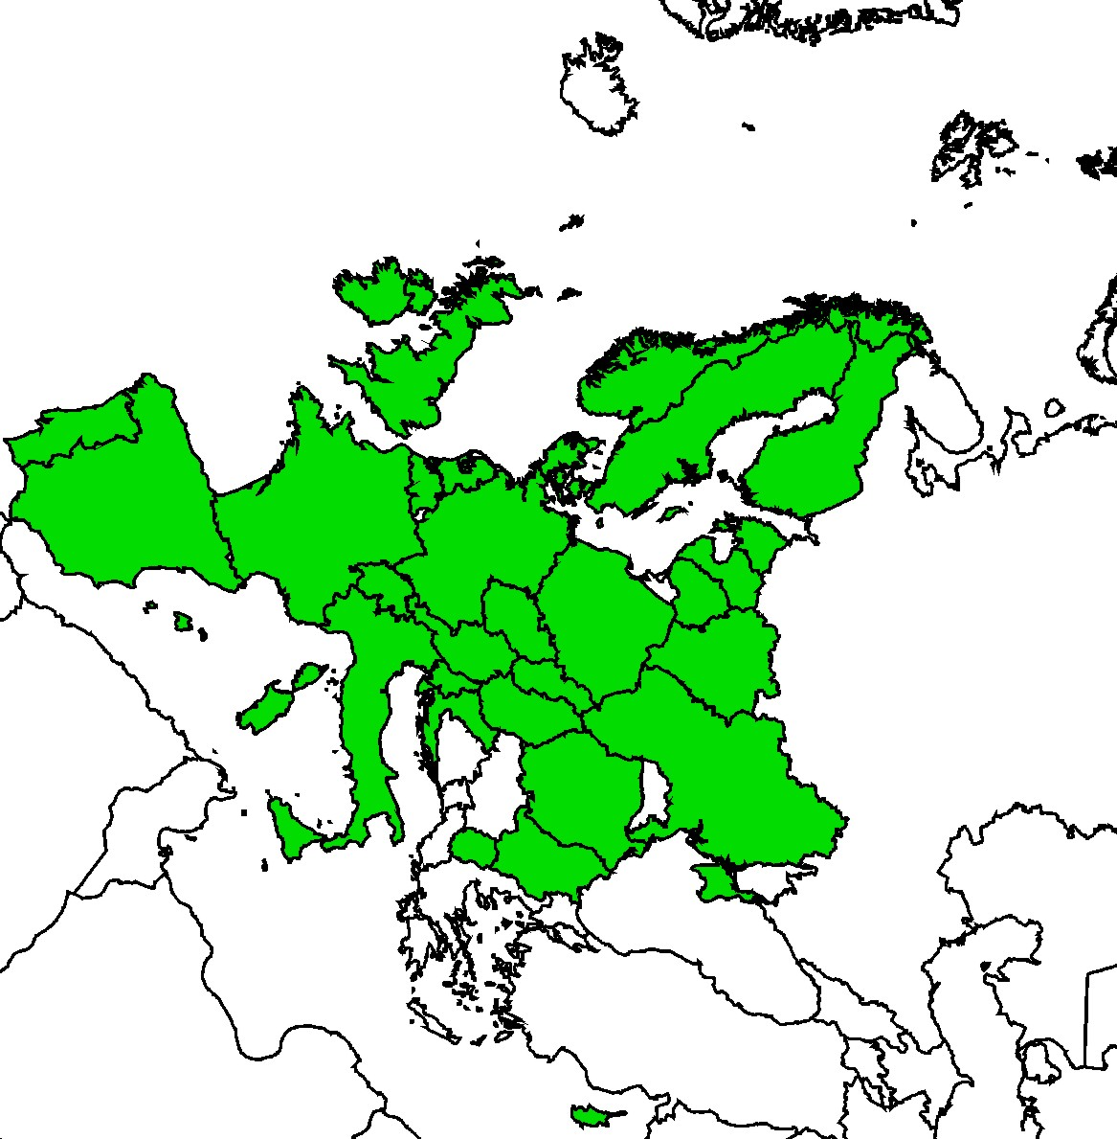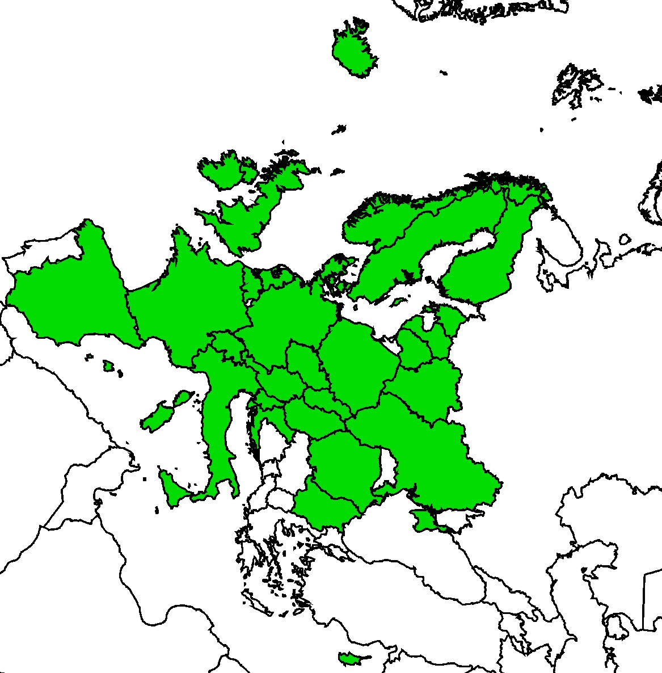
Fig. 1. Gridded emissions reporting by Parties in the EMEP area

Besides, for the modeling purpose it is important to have quantitative estimates of emission data uncertainty in a form of error intervals of the reported emission values. This is needed for the evaluation of possible maximum and minimum scenarios of pollution levels in the EMEP region. Range of uncertainties of the officially reported emission data is submitted only by 10 EMEP countries and can differ from 19% (Cyprus) to 491% (Denmark) for HMs and from 35% (France) to 723% (Denmark) for POPs.
It should be also mentioned that further improvement of completeness of officially reported data and updatable expert emission estimates are needed for better quality assessment of pollution levels in the EMEP domain.

3. Chemical composition of emissions
Mercury
The character of Hg dispersion in the atmosphere and transport from one region to another are largely affected by physicochemical properties of Hg atmospheric species. Poorly soluble and relatively inert gaseous elemental mercury (GEM) can drift in the air for months providing transport of Hg mass between different regions of the planet. In contrast, oxidized Hg species – gaseous oxidized mercury (GOM) and particle bound mercury (PBM) – are easily removed from the air by precipitation scavenging or the surface uptake [Selin, 2009; Travnikov, 2011; AMAP/UNEP, 2013]. Therefore, proportion of anthropogenic emissions that deposits locally or regionally depends on speciation of Hg emissions that differs significantly for different emission sectors. Figure 2 shows model estimates of mercury deposition in the EMEP region performed with different assumptions on speciation of Hg anthropogenic emissions.
a 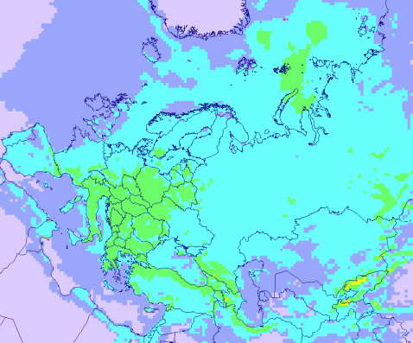 | g/km²/y  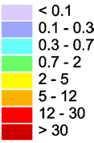 | b 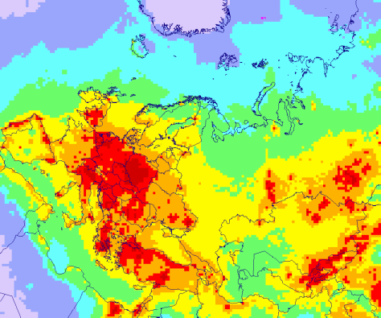
Fig. 2. Annual Hg deposition in the EMEP region simulated for different speciation of Hg emissions: (a) – all Hg emissions are treated as GEM; (b) – all Hg emissions are treated as oxidized Hg (GOM and PBM). Total Hg emission was kept the same in both cases.

Information on speciation of Hg anthropogenic emissions is not reported by the Parties to CLRTAP. Therefore, expert estimates of the mercury emission speciation have been made by MSC-E. The current approach is based on utilizing the AMAP/UNEP global Hg emission inventory for 2010 [AMAP/UNEP, 2013]. This inventory is used to evaluate average speciation of Hg emissions in different EMEP countries. These country-specific ratios are applied to the EMEP gridded emission data to obtain speciation of Hg emissions for modeling.
This approach contains considerable uncertainties. First of all, the original global AMAP/UNEP inventory was developed using consistent statistical approach on a global scale and, probably, did not reflect peculiarities of individual EMEP countries. Secondly, sector-specific speciation of Hg emissions is not available from this inventory. And finally, some recent researches involving both Hg modeling and contemporary measurements of speciated Hg in the ambient air suppose possible systematic bias in speciation of existing inventories overestimating proportion of oxidized Hg species in anthropogenic emissions [Amos et al., 2012; Zhang et al., 2012; Kos et al., 2013]. Therefore, involvement of national data and experts to evaluation of Hg emission speciation could significantly improve quality of pollution assessment in the EMEP countries.

PCDD/Fs and PCBs
Some of the POPs, defined in the Protocol on POPs, e.g. PCDD/Fs and PCBs, are released into the environment as complex mixtures of different congeners that represents a challenge for the evaluation of their emissions [Breivik et al., 2004]. Individual congeners have their own physical-chemical properties that differ substantially and depend on environmental characteristics (e.g. temperature). In particular, lower chlorinated congeners are semi-volatile, partitioning in the atmosphere between gaseous and particulate phase, and exchange efficiently with terrestrial and aquatic surfaces, while more chlorinated congeners are less volatile and tend to associate with atmospheric aerosol particles that control their transport. Differences in the properties lead to differential removal and fractionation of particular congeners in course of their long-range transport that have been observed in several studies [e.g. Meijer et al., 2003; Schuster et al., 2010] and obtained in model simulations [von Waldow et al., 2010; Gusev et al., 2007].
At present officially reported emission data of the EMEP countries do not provide this kind of information. Particularly, national emission inventories are reporting total PCDD/F emission in the toxicity units and total PCB emission in mass units without splitting on particular congeners. For modeling purposes the information on the congener-specific gridded emissions of PCDD/Fs and PCBs was obtained from expert emission inventories [e.g. Breivik et al., 2007; Pacyna et al., 2003] (Fig.3). However, these estimates characterize the situation for the beginning of 2000s and earlier that might not be applicable for the current period.
In course of model assessment of PCDD/F pollution levels in the EMEP countries MSC-E peformed a number of studies directed to the analysis of available data on the emissions of dioxins and furans to the environment. These studies were mostly focused on the examenation of uncertanties of PCDD/F emissions as well as on elaboration of experimental scenario emissions for modelling that allowed to explain observed pollution levels. Results of these research activities are given in Annex I.
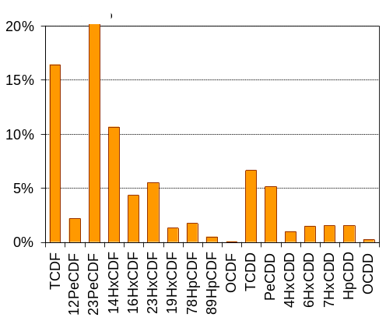
Fig. 3. Congener composition of PCDD/Fs emissions (EMEP region). Expert estimates POPCYCLING-Baltic project [Pacyna et al., 2003].
Refinement of estimates of congener composition of emissions is of importance for further progress in the assessment of pollution levels. Further work in this direction could be performed in course of updating of available expert estimates of congener-specific emissions for the EMEP region and for the global scale, including also estimation of emissions from particular source categories.

4. Temporal variation of emissions
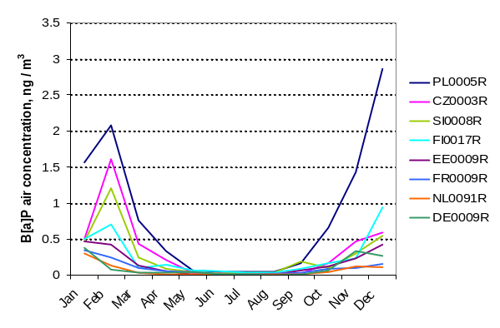
Fig. 4. Seasonal variations of B[a]P air concentrations observed at the EMEP
monitoring sites in 2012 (ng/m³)
The contamination levels (air concentrations and deposition fluxes) of HMs and POPs are subject to essential temporal variability [Shatalov et al., 2015]. It has been found that average seasonality of modelled and observed Pb and Cd levels is about 40-50% of the annual average. Intra-annual variability of some POPs (e.g. PAHs, PCDD/Fs, PCBs) can be even stronger. For instance, as shown in Figure 4, difference between observed winter time and summer time B[a]P air concentrations can reach an order of magnitude and more.
Temporal variability of HM and POP pollution levels can be conditioned by both environmental factors and temporal variability of emissions from various source categories. Parameterization of emission temporal variability was developed for B[a]P. Temporal variations of emissions were constructed individually for four source categories (residential heating, road transport, industrial processes, waste incineration and other), which determined over 90% of total emissions. Model parameterization of temporal variability of emissions from residential heating used the approach introduced in [Aulinger et al., 2010] based on the dependence of emissions from this sector on ambient temperature. For the other emission sectors temporal variations of emissions were assumed to be such as used in LOTOS/EUROS model [Schaap et al., 2005]. According to the model estimates, effect of emission seasonal variations on annual means may reach up to 40%. The information on emission temporal variations is required for reliable assessment of exceedances of target values in Europe. Detailed description of this investigation can be found in Annex III and in [Shatalov et al., 2012].
Temporal variations of HM emissions are not included at present in the modelling because information on seasonal variability of emissions is not available. However, both observations and modelling results show that seasonal variability of Pb and Cd levels makes up around 30-40% on average (Fig. 5).

a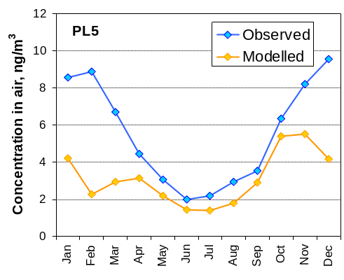 b 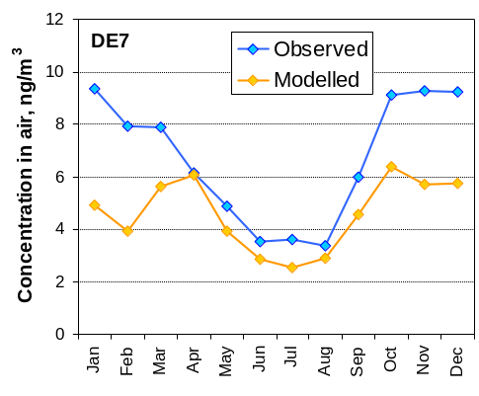
Fig. 5. Modelled and observed monthly mean concentrations of lead at Polish stations PL5, averaged over 2005-2012 period (a) and at German station DE7, averaged over 2000-2012 period (b)

This variability in modelling results is explained entirely by meteorological factors. Introduction of temporal variability of HM emissions could favor improvement of agreement between calculated and observed pollution levels. Similarly, information on seasonal changes of POP emissions (e.g. for PAHs, PCDD/Fs, and PCBs) can help to reduce uncertainties in the evaluation of POP pollution levels. However, further research is required to quantify the effect of more detailed temporal variability of emissions.

5. Vertical distribution of emissions
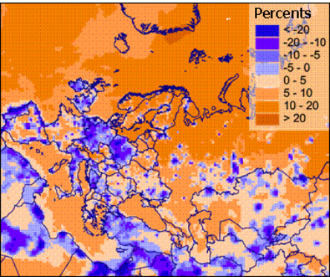
Fig.6. Relative difference between Pb deposition, calculated with and without use of vertical distribution of emissions. Negative values mean decrease and positive – increase of deposition.
Vertical distribution of emissions is important for modelling of atmospheric transport of pollutants. Since wind velocity tends to increase with altitude, pollutants emitted at higher altitudes tend to transport over longer distances compared to those at lower layers. Besides, contributions of wet and dry components to total deposition depend on distribution of pollutants in the column of atmosphere along the vertical. When vertical distribution of emissions is taken into account, simulated deposition flux decreases nearby large emission sources and increases in other regions of the EMEP domain (Fig. 6). This effect is expected to be even stronger when moving to a finer resolution grid.
When applying vertical distribution of HM emissions it has been assumed that each source category is characterized by specific emission height, following [Berdowski et al., 1997]. Emissions are distributed along the vertical between three lowest model layers, based on contributions of emission source categories to total emission in the EMEP region officially reported for 2000 [Travnikov and Ilyin, 2005]. It should be noted that the approach does not take into account possible rise of emission plume.
Vertical distribution of HM and POP emissions could be updated by linking atmospheric releases from particular source categories to their emission heights (or range of heights). Information on large point sources (LPS) such as physical stack height, gas outflow velocity, top diameter of a stack and gas temperature as well as meteorological information can facilitate improvement of vertical distribution due to considering rise or emission plumes [Briggs, 1984; Houyoux, 1998]. However, for regular operational calculations it seems feasible to use aggregated information of emission height for different source categories [Bieser et al., 2011].

6. Global emission inventories
Atmospheric dispersion of a number of pollutants under the scope of the Convention, including Hg and some POPs (PCDD/Fs, PCBs and HCB), is not limited by a regional scale. Given their persistence in the environment and long residence time in the atmosphere these substances can travel over long distances. The potential to long-range transport of these pollutants is also enhanced by their ability to be re-emitted after deposition to the ground that leads to multi-hop dispersion. As a result pollution levels in the EMEP region can be significantly affected by emissions from distant sources located in other regions or even continents (Fig. 7). In particular, it has been estimated that deposition of Hg from direct anthropogenic sources in Europe is derived almost equally from domestic and foreign emissions [AMAP/UNEP, 2015]. Model simulations for selected POPs, performed in the framework of the TF HTAP multi-model assessment, showed that contribution of intercontinental transport from the source regions to the pollution levels in the receptor regions could be about 10% and more for some of the regions [Gusev et al., 2010].
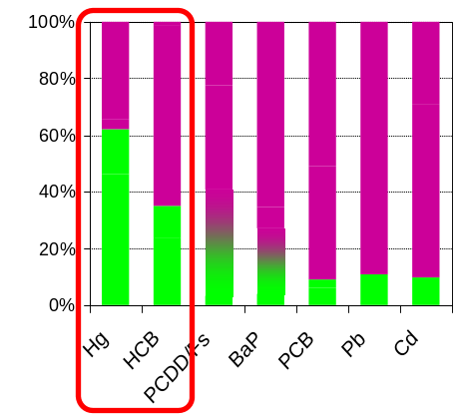

Fig.7. Contribution of regional vs. global sources to HM and POP pollution
Besides, even deposition of pollutants with relatively short residence time in the atmosphere (Pb, Cd, B(a)P etc.) is influenced by sources located outside the EMEP region, particularly, in the Asian countries with growing economies. Therefore, correct consideration of these sources is required through evaluation appropriate boundary conditions.
Available emission inventories for HMs and POPs on a global scale are summarized in Table 2. Relatively favorable situation is with global emission data for mercury (Fig. 8). There are two recent inventories of gridded Hg emissions developed for a number of years. The only gridded emission dataset for Pb relates to 1989. It has been updated for mid-nineties but without spatial distribution. Only aggregated emission estimates without spatial distribution of emission sources are available for Cd and also relate to mid-nineties. As for POPs, global gridded emission data are available only for PCBs that include historical estimates from 1930 and future projections up to 2100. For HCB, PAHs, and PCDD/Fs available inventories of global emissions provide information on national emission totals without spatial distribution and most of them characterize levels of releases in mid-1990s or beginning of 2000s. For modeling purposes global PCDD/F experimental emission scenario was constructed on the basis of the information on dioxins and furans releases compiled under the UNEP Stockholm Convention (Annex I).
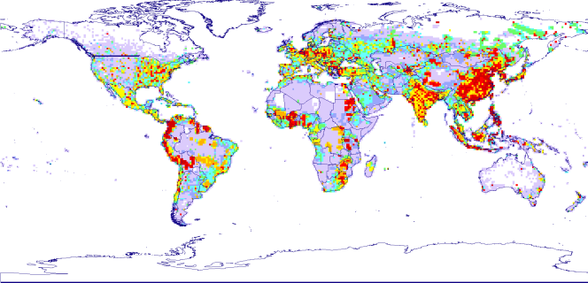
Fig.8. Global Hg emissions inventory, 2010 [AMAP/UNEP, 2013]

Table 2. Available global emission inventories for heavy metals and POPs
Chemical | Period | Spatial resolution | Data source | Reference
Heavy metals
Pb | 1989 | 1°×1° |  | Pacyna et al., 1995
Pb | 1995 | n/a |  | Pacyna and Pacyna, 2001
Cd | 1995 | n/a |  | Pacyna and Pacyna, 2001
Hg | 1990-2010 | 0.5°×0.5° | AMAP^{(a)} | AMAP/UNEP, 2013
Hg | 1970-2008 | 0.1°×0.1° | EDGAR/JRC^{(b)} | Muntean et al., 2014
POPs
PCBs | 1930-2100 | 1°×1° | NILU^{(c)} | Breivik et al., 2007
PAHs | 2004 | n/a |  | Zhang and Tao, 2009
HCB | 1995 | n/a |  | Bailey, 2001
PCDD/Fs | Ref. years between 1999 and 2009 | n/a |  | Cao et al., 2013
^{(a)} http://www.amap.no/mercury-emissions/
^{(b)} http://edgar.jrc.ec.europa.eu/edgar_v4tox1/
^{(c)} http://www.nilu.no/projects/globalpcb/globalpcb2.htm

Further improvements of global emission data for HMs and POPs should include update of existing inventories with more recent data and development of absent gridded data for Cd, HCB, PAHs, and PCDD/Fs.

7. Historical and natural emissions
HM and POP pollution levels are controlled by various emission sources, particularly, primary anthropogenic emissions to the atmosphere and other media, as well as natural and secondary emissions (re-mobilization of previously deposited pollutants from soils, water bodies, etc.). Along with anthropogenic emissions, the contribution of secondary sources is an important factor that needs to be addressed in studies of contemporary levels of pollution. While primary emissions are decreasing or ceasing due to emission control measures, the role of secondary emissions can increase or they can even dominate (Fig. 9).
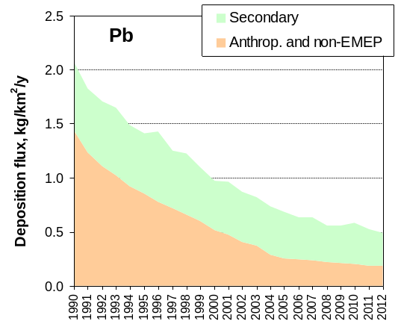
Fig. 9. Deposition fluxes of lead caused by secondary and anthropogenic sources within EMEP region and by non-EMEP sources
In particular, along with primary anthropogenic emissions, lead and cadmium are emitted to the atmosphere as a result of wind re-suspension of dust, sea salt emission, volcanic activity, wild forest fires, and biogenic emissions [Nriagu, 1989]. Anthropogenic emissions to the atmosphere over long period of time (decades – hundreds of years) lead to long-term accumulation of deposited HMs and increase of their concentrations in the top layer of soils, water bodies, etc. Thus, wind re-suspension of metals from surfaces of terrestrial and aquatic media can significantly contribute to the pollution in the EMEP region [Dore et al., 2014, Amato et al., 2014, Laidlaw et al., 2012]. It is likely that estimates of wind re-suspension currently used for model assessment of HM pollution are characterized by considerable uncertainties and may partly compensate possible underestimation of the anthropogenic emissions. For improvement of estimation of secondary emissions information on contemporary concentrations of Pb and Cd in top soils of the EMEP region is needed.
Experience of the Working Group on Effects (WGE) in dynamic modelling of HMs in soils could be highly valuable for establishing link between historical anthropogenic emissions, HM concentrations in soils and their re-suspension.
Current Hg emissions to the atmosphere include, along with direct anthropogenic emissions, contribution of natural sources (weathering of Hg containing rocks, volcanic and geothermal activities) and secondary emissions. The latter comprise re-emission to the atmosphere of previously deposited Hg which originally comes from anthropogenic and natural sources. According to the recent estimates natural and secondary sources contribute around 75% in sum to the total Hg emissions on a global scale [Mason et al., 2012; AMAP/UNEP, 2013]. Therefore, these source types can significantly affect levels of Hg air concentration and deposition in the EMEP domain [Ilyin et al., 2015; AMAP/UNEP, 2015]. The current modeling approach to Hg simulation both on global and regional scales applies expert estimates of Hg emissions from natural and secondary sources based on literature data [Travnikov and Ilyin, 2005; Travnikov and Ilyin, 2009; Travnikov et al., 2009]. Besides, to improve the estimates of these source types and their contribution to pollution levels in the EMEP countries a multi-media version of the GLEMOS model for Hg is currently under development. Along with model parameterizations, application of this multi-media approach will require information on historical Hg emissions in the EMEP and other regions of the world.
Secondary emissions of POPs to the atmosphere are in general estimated from primary releases to the media in course of model simulations. The estimates of secondary emissions are characterized by significant uncertainties as they depend on many factors including historical emissions as well as changes of meteorology, climate, and characteristics of environmental compartments over the period of their past use. Among the POPs considered in the EMEP modeling activities global inventory of historical emissions is currently available only for PCBs [Breivik et al., 2007] (Fig. 10 and 11). For other POPs there is a lack of inventories, that include historical emissions, and thus further work on their elaboration is required to refine model assessment of contemporary levels of pollution.

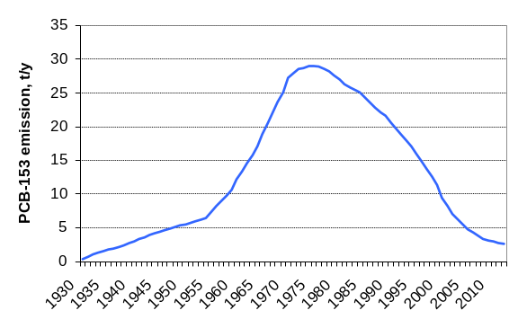 | 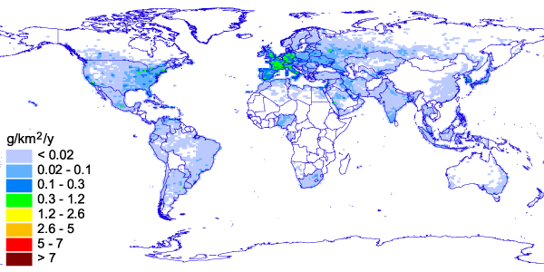
Fig. 10. Scenario of temporal variations of global emission of PCB-153 to the atmosphere in the period 1930-2013 | Fig. 11. Spatial distribution of PCB-153 in 2013 over global domain with resolution 1ºx1º

Model evaluation of HCB global transport and fate was performed on the basis of experimental emission dataset, which described contemporary levels of HCB releases as well as historical emissions for the period from 1945 to 2013 (Fig. 12). Three scenarios of historical HCB emissions (maximum, average and minimum), had been elaborated previously [Shatalov et al., 2010], were updated and used for modelling of long-term accumulation of the pollutant in the environmental media (Annex II).
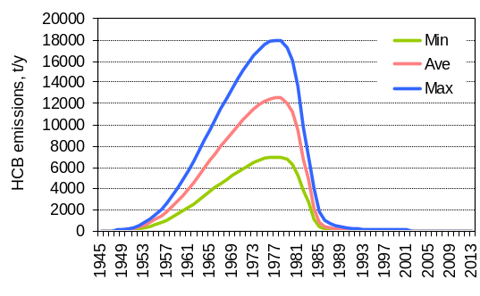
Fig. 12. Estimates of historic and current HCB
emissions under the three emission scenarios (minimum, average, and maximum) for the period 1945-2013, t/y
For some of the POPs (e.g. for HCB, PCDD/Fs) it is important also to take into account direct emissions to soils and water bodies to evaluate their accumulation in surface media and subsequent re-emission [Theloke et al., 2010]. Direct releases to land, water, and residues are taken into account in the national emissions of global PCDD/F inventory of the UNEP Stockholm Convention (SC). (Fig. 13) At the same time, the methodology on the inventory of POP emissions applied in CLRTAP is oriented on the atmospheric emissions. Thus, for further improvement of POP pollution estimates the elaboration of inventories for these emission pathways is appreciated and collaboration with the UNEP SC activities on the evaluation of emissions is of importance.
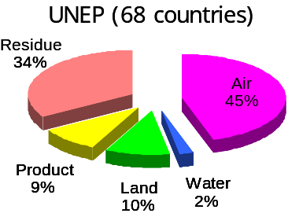
Fig. 13. Emissions of PCDD/Fs to the atmosphere and other media [Cao et al., 2013]
8. Summary
Emission data for HMs and POPs have been characterized from the viewpoint of their use for the operational modeling within EMEP. Various emission parameters which affect quality of the model assessment have been discussed along with characterizing of their uncertainties. Importance of different emission parameters and their influence on quality of the assessment results varies considerably for simulation of different pollutants. This fact should be taken into account when planning improvement of the emission data. Table 3 characterizes the key emission parameters for HMs and POPs in terms of their priority for the further improvement. It should be noted that lower priority level does not mean that no improvements are needed for this emission parameter but rather determines order of their implementation.
Table 3. Key emission parameters affecting quality of model estimates
Emission parameter | Pb and Cd | Hg | PAHs | PCDD/Fs and PCBs | HCB
Quality of gridded anthropogenic emissions | 1 | 2 | 1 | 1 | 2
Chemical composition | - | 1 | - | 2 | -
Temporal variation | 2 | 6 | 2 | 6 | 5
Vertical distribution | 3 | 7 | 3 | 7 | 6
Global emissions inventory | 4 | 3 | 4 | 3 | 3
Historical emissions | 5 | 4 | 5 | 4 | 1
Emissions to other media | 6 | 5 | 6 | 5 | 4
- First priority; - Second priority; - Third priority

As seen from Table 3, quality of gridded emission data (including completeness of reported data and quality of expert estimates used for gap filling) is among the first priority parameters for all HMs and POPs. Other parameters with the highest priority include chemical composition of emissions (when it is relevant), temporal variation (for PAHs) and historical emissions (for HCB). Lower priority parameter, which is still important for all the substances, is global emissions inventory. Besides, pollutants with marked multi-media properties (Hg, HCB, PCDD/Fs and PCBs) require information on historical emissions and releases to other environmental media (soil, seawater, etc.). On the other hand, predominantly airborne substances (e.g. Pb, Cd and PAHs) can be more affected by temporal variation of emissions and vertical distribution of emission sources.

References
AMAP/UNEP [2013] Technical Background Report for the Global Mercury Assessment 2013. Arctic Monitoring and Assessment Programme, Oslo, Norway/UNEP Chemicals Branch, Geneva, Switzerland. vi + 263 pp.
AMAP/UNEP [2015] Global Mercury Modelling: Update of Modelling Results in the Global Mercury Assessment 2013. Arctic Monitoring and Assessment Programme, Oslo, Norway/UNEP Chemicals Branch, Geneva, Switzerland. iv + 32 pp.
Amato F., Alastuey A.., de la Rosa J., Castanedo G.Y., de la Campa S. A. M., Pandolfi M., Lozano A., González J. C., and Querol X. [2014] Trends of road dust emissions contributions on ambient air particulate levels at rural, urban and industrial sites in southern Spain. Atmos. Chem. Phys., 14, 3533–3544.
Amos H.M., Jacob D.J., Holmes C.D., Fisher J.A., Wang Q., Yantosca R.M., Corbitt E.S., Galarneau E., Rutter A.P., Gustin M.S., Steffen A., Schauer J.J., Graydon J.A., St. Louis V.L., Talbot R.W., Edgerton E.S., Zhang Y., Sunderland E. M. [2012] Gas-particle partitioning of atmospheric Hg(II) and its effect on global mercury deposition. Atmos. Chem. Phys., 12, 591–603.
Aulinger A., V. Matthias and M. Quante [2010]. An Approach to Temporally Disaggregate Benzo(a)pyrene Emissions and Their Application to a 3D Eulerian Atmospheric Chemistry Transport Model, Water, Air, & Soil Pollution, vol. 216, No. 1-4, pp. 643-655.
Bailey R.E. [2001] Global hexachlorobenzene emissions. Chemosphere 43, pp. 167-182.
Berdowski J.J.M., Baas J., Bloos J.P.J., Visschedijk A.J.H. and P.Y.J.Zandveld [1997] The European Emission Inventory of Heavy Metals and Persistent Organic Pollutants for 1990. TNO Institute of Environmental Sciences, Energy Research and Process Innovation, UBA-FB report 104 02 672/03, Apeldoorn, 239 p.
Bieser J., Aulinger A., Matthias V., Quante M., and Denier van der Gon H. [2011] Vertical emission profiles for Europe based on plume rise calculations., Environ. Pollut., 159, 2935–2946, doi:10.1016/j.envpol.2011.04.030.
Breivik K., R. Alcock, Y.-F.Li, R. E. Bailey, H. Fiedler, J.M. Pacyna [2004] Primary sources of selected POPs: regional and global scale emission inventories. Environmental Pollution 128, 3–1.
Breivik K., Sweetman A., Pacyna J.M., Jones K.C. [2007] Towards a global historical emission inventory for selected PCB congeners - A mass balance approach-3. An update. Science of the Total Environment, vol. 377, pp. 296-307.
Briggs G. A. [1984] Plume rise and buoyancy effects, Atmospheric Sciences and Power Production, D. Randerson, ed., DOE/TIC27601 (DE84005177), TN, 850 pp., Technical Information Center, U.S. Dept. of Energy, Oak Ridge, USA
Cao Z., Fiedler H., Wang B., Zhang T., Yu G., Huang J., S.Deng [2013] Economic status as a determinant of national PCDD/PCDF releases and implications for PCDD/PCDF reduction. Chemosphere, 91, pp.328-335.
Dore A. J., Hallsworth S., McDonald A. G., Werner M., Kryza M., J. Abbot, Nemitz E., Dore C. J., Malcolm H., Vieno M., Reis S., Fowler D. [2014] Quantifying missing annual emission sources of heavy metals in the United Kingdom with an atmospheric transport model. Science of the Total Environment, 479 –480 171–180.
Gusev A., E. Mantseva, O. Rozovskaya, V. Shatalov, N. Vulykh, W. Aas, K. Breivik [2007] Persistent Organic Pollutants in the Environment. EMEP Status Report 3/2007.
Gusev A., MacLeod M., Shatalov V., Bartlett P., Hollander A., Gong S., and G. Lammel [2010] Global and regional modeling of POPs. In: Dutchak, S. and A. Zuber [2010] Hemispheric Transport of Air Pollution 2010. Part C: Persistent Organic Pollutants, pp. 127-166. Air Pollution Studies No. 19. ECE/EB.AIR/102. United Nations Publication.
Houyoux M.R. [1998] Technical report: plume rise algorithm summary for the Sparse Matrix Operator Modeling System (SMOKE). Prepared for North Carolina Department of Environment and Natural Resources, UNC, Chapel Hill, North Carolina, ENV 98TR004eTR0v1.0
Ilyin I., Rozovskaya O., Travnikov O., Varygina M. [2015] Heavy metals: Analysis of long-term trends, country-specific research and progress in mercury regional and global modelling. EMEP Status Report 2/2015.
Kos G., Ryzhkov A., Dastoor A., Narayan J., Steffen A., Ariya P.A., Zhang L. [2013] Evaluation of discrepancy between measured and modelled oxidized mercury species. Atmospheric Chemistry and Physics, 13 (9), pp. 4839-4863.
Laidlaw M.A.S., Zahran S., Mielke H.W., Taylor M.P., Filippelli G.M. [2012]. Re-suspension of lead contaminated urban soil as a dominant source of atmospheric lead in Birmingham, Chicago, Detroit and Pittsburgh, USA. Atmospheric Environment, 49, 302-310.
Mareckova K., Wankmueller R., Pinterits M. and B.Ullrich [2015] Inventory Review 2015. Review of emission data reported under the LRTAP Convention and NEC Directive. Stage 1 and 2 review. Status of gridded and LPS data. ISBN 978-3-99004-359-2.
Mason, R.P., A.L. Choi, W.F. Fitzgerald, C.R. Hammerschmidt, C.H. Lamborg, A.L. Soerensen and E.M. Sunderland [2012] Mercury biogeochemical cycling in the ocean and policy implications. Environmental Research, 119:101-117.
Meijer S.N., Ockenden W.A., Steinnes E., Corrigan B.P., Jones K.C. [2003] Spatial and temporal trends of POPs in Norwegian and UK background air: Implications for global cycling. Environ. Sci. Technol., 37, 454–461.
Muntean M, Janssens-Maenhout G., Song S., Selin N.E., Olivier J.G.J., Guizzardi D, Maas R. and F. Dentener [2014] Trend analysis from 1970 to 2008 and model evaluation of EDGARv4 global gridded anthropogenic mercury emissions. Sci.Total Environ. 494–495, pp.337–350.
Nriagu J.O. [1989] A global assessment of natural sources of atmospheric trace metals. Nature 338, 47-49.
Pacyna J. M., Scholtz M. T. and Y.-F.Li [1995] Global Budgets of Trace Metal Sources, Environmental Reviews, 3, 145-159.
Pacyna J.M. and E.G.Pacyna [2001] An assessment of global and regional emissions of trace metals to the atmosphere from anthropogenic sources worldwide. Environmental Reviews, 9, pp.269-298.
Pacyna J.M., K. Breivik J. Münch J. Fudala [2003] European atmospheric emissions of selected persistent organic pollutants, 1970-1995. Atmos. Environ., vol. 37, pp.S119-S131.
Schaap M., M. Roemer, F. Sauter, G. Boersen, R. Timmermans, and P. G. H. Builtjes [2005] LOTOS-EUROS: documentation, TNO report B&O-A R 2005/297.
Schuster J., Gioia R., Breivik K., Steinnes E., Scheringer M., Jones K.C. [2010] Trends in European Background Air Reflect Reductions in Primary Emissions of PCBs and PBDEs. Environ. Sci. Technol., 44, 6760–6766.
Selin N.E. [2009] Global biogeochemical cycling of mercury: A review. Annu. Rev. Environ. Resour. 34, 43-63.
Shatalov V., Gusev, S. Dutchak, O. Rozovskaya, V. Sokovykh, N. Vulykh, W. Aas, K. Breivik [2010] Persistent Organic Pollutants in the Environment. EMEP Status Report 3/2010.
Shatalov V., I. Ilyin, A. Gusev, O. Rozovskaya, V. Sokovykh, O. Travnikov [2012] Heavy metals and persistent organic pollutants: New developments. EMEP/MSC-E Technical Report 4/2012.
Shatalov V., I. Ilyin, A. Gusev, O. Travnikov [2015] Heavy Metals and Persistent Organic Pollutants: Multi-scale modelling and trend analysis methodology. MSC-E Technical Report 1/2015.
Theloke J., Li Y.F., Breivik K., van der Gon H.D., Pacyna J., Panasiuk D., Sundseth K. and S. Tao [2010] Emission Inventories and Projections for Assessing Hemispheric or Intercontinental Transport of Persistent Organic Pollutants. In: Dutchak, S. and A. Zuber, 2010. Hemispheric Transport of Air Pollution 2010. Part C: Persistent Organic Pollutants, pp. 89-125. Air Pollution Studies No. 19. ECE/EB.AIR/102. United Nations Publication.
Travnikov O. [2000] Uncertainty Analysis of HM Long-range Atmospheric Transport Modelling. MSC-E Technical Note 9/2000.
Travnikov O. [2011] Atmospheric Transport of Mercury, in Environmental Chemistry and Toxicology of Mercury (eds G. Liu, Y. Cai and N. O'Driscoll), John Wiley & Sons, Inc., Hoboken, NJ, USA. doi: 10.1002/9781118146644.ch10.
Travnikov O. and I. Ilyin [2005] Regional Model MSCE-HM of Heavy Metal Transboundary Air Pollution in Europe. EMEP/MSC-E Technical Report 6/2005.
Travnikov O. and I. Ilyin [2009] The EMEP/MSC-E mercury modeling system. In: Mason, R. and N. Pirrone (Eds.). Mercury Fate and Transport in the Global Atmosphere, pp. 571-587. Springer.
Travnikov O., J.E. Jonson, A.S. Andersen, M. Gauss, A. Gusev, O. Rozovskaya, D. Simpson, V. Sokovyh, S. Valiyaveetil and P. Wind [2009]. Development of the EMEP global modelling framework: Progress report.
von Waldow H., MacLeod M., Jones K., Scheringer M., and Hungerbühler K. [2010] Remoteness from emission sources explains the fractionation pattern of polychlorinated biphenyls in the Northern Hemisphere, Environ. Sci. Technol., 44, 6183–6188.
Zhang, L., Blanchard, P., Johnson, D., Dastoor, A., Ryzhkov, A., Lin, C.-J., Vijayaraghavan, K., Gay, D., Holsen, T. M., Huang, J., Graydon, J.A., St. Louis, V. L., Castro, M. S., Miller, E. K., Marsik, F., Lu, J., Poissant, L., Pilote, M. and Zhang, K. M. [2012] Assessment of modeled mercury deposition over the Great Lakes region. Environ. Pollut. 161, 272–283.
Zhang Y. and S.Tao [2009] Global atmospheric emission inventory of polycyclic aromatic hydrocarbons (PAHs) for 2004. Atmospheric Environment, vol.43, issue 4, pp.812-819.

Annex I
PCDD/F EMISSION DATA FOR MODEL ASSESSMENT
Polychlorinated dibenzo(p)dioxins and dibenzofurans are unintentional by-products released into the environment during various combustion processes. Along with direct emissions due to anthropogenic activities, dioxins and furans can also be re-mobilized from surface media (e.g. soil, water bodies) where they were accumulated in course of past industrial and agricultural activities. Analysis performed in the studies of K.Breivik et al. [2004], H.Fiedler [2007], and K.Mareckova et al. [2012] indicated that available national inventories of PCDD/F emissions most likely do not cover all potential sources of PCDD/Fs releases to the atmosphere and thus could not explain observed levels of pollution.
In course of model assessment of PCDD/F pollution levels in the EMEP countries MSC-E peformed a number of studies directed to the analysis of available data on the emissions of dioxins and furans to the environment. These studies were mostly focused on the examenation of uncertanties of PCDD/F emissions as well as on elaboration of experimental scenario emissions for modelling that allowed to explain observed pollution levels. In particular, collection of information on PCDD/F emissions in the EMEP countries and their congener composition was performed in 2001 [Vulykh and Shatalov, 2001]. It was indicated that major source categories of PCDD/F emissions included combustion of organic fuels, inciniration of wastes, and secondary processing of non-ferrous metals. Different congeners provide different contributions to overall emission of PCDD/Fs. According to the data collected from literature three homologue groups of PCDD/F congeners, in particular, PeCDFs, HxCDFs, and PeCDDs, contributed more than 70% to the emitted dioxins and furans mixture toxicity. Due to essential differences in physical-chemical properties of toxic PCDD/F congeners it is important to define congener composition of emitted PCDD/F mixture. This information for modelling purpose is obtained from the data of POPCYCLING-Baltic project [Pacyna et al., 1999]. However, these estimates characterize the situation for the beginning of 2000s and earlier that might not be applicable for the current period of time.
Analysis of reported PCDD/F emission data for the Baltic Sea region was performed in framework of the BalticPOPs research program [Shatalov et al., 2012a; Wiberg et al., 2013]. One of the aims of this study was to trace the origin of dioxins and furans in the Baltic Sea region and to evaluate whether the observed PCDD/F air concentrations can be reproduced by the modeling using officially reported PCDD/F emissions. MSC-E has contributing to this study with model assessment of pollution and elaboration of experimental scenario emissions. In particular, combined analysis of air monitoring and modelled data showed that the use of officially reported emissions for modeling lead to underestimation of measured air concentrations and deposition fluxes. The largest disagreement between measurements performed with indication of air masses transport direction and modeled data was obtained for episodes with transport from the south southeast (SSE) and south southwest (SSW) compass sectors. Thus the most important source regions for the Baltic Sea area were likely central and eastern parts of Europe which could be characterized by underestimated emissions. Several modeling experiments with regionally adjusted emission scenarios showed that increase of emissions in these regions could substantially reduce underestimation of observed pollution levels.
Later on this work was continued for 17 toxic congeners of PCDD/Fs on the basis of extended set of measurements [Shatalov et al., 2012b]. Application of this approach and construction of experimental scenario emissions for modeling permitted to improve agreement of modeled values with available measurements and to estimate the likely levels of PCDD/F releases to the environment, which exceeded officially reported emissions about five times. At the same time, further work is required to refine national inventories of dioxins and furans emissions in the countries of Central and Eastern Europe to improve assessment of pollution.
Along with anthropogenic emissions of the EMEP countries, additional contribution to the pollution levels can be made by emissions from non-EMEP sources and secondary emissions from media (e.g. soil, water bodies). For this purpose experimental scenario of global emissions of PCDD/Fs was prepared for modeling using the data of the UNEP SC inventory. This inventory is being compiled under SC using the methodology of the UNEP Standardized Toolkit [Fiedler, 2007; Fiedler et al., 2012; UNEP, 2013]. More detailed description of this experimental scenario can be found below and in the MSC-E Technical Report [Shatalov et al., 2014].

Experimental scenario of global PCDD/F emissions
Global PCDD/F experimental emission scenario for modeling was constructed on the basis of the information on dioxins and furans releases compiled under the UNEP SC [Fiedler, 2007; Fiedler et al., 2012]. National inventories of annual PCDD/F emissions were available for 68 countries representing the level of emissions during the recent decade. These inventories include data on total PCDD/F emissions constructed in accordance with the UNEP Toolkit using detailed information on PCDD/F releases from ten source groups. Major contributions of these source groups to PCDD/F emission are shown in Fig.1.
UNEP (68 countries)  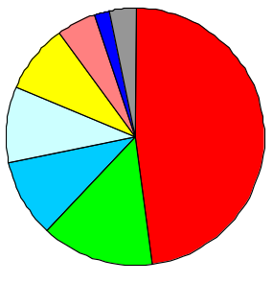 | 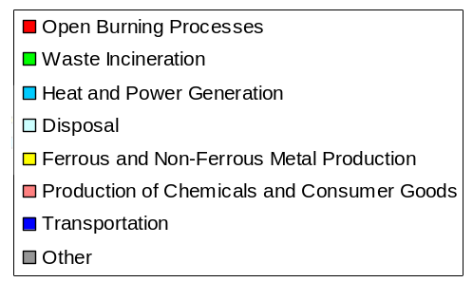
Fig. 1. Contributions of major emission source groups to total PCDD/F emission based on the data provided by 68 countries to the UNEP Stockholm Convention on POPs
In addition, results of the research performed by Z.Cao et al. [2013] were used. In this study the correlation between the intensity of PCDD/F emissions in the countries and their economic status was evaluated. It was found that PCDD/F emissions from a country and its gross domestic product (GDP) as well as economic level correlated with each other. The regression relation between annual PCDD/F releases per billion of GDP (Release, g TEQ) and GDP per person (GDPpers, USD) has the form:
Release = A × (GDPpers) ^{– B} (1)
where the constants A and B are defined by linear regression between Log(Release) and Log(GDPpers) (Fig.2).
At first step, global data on PCDD/F emissions to the atmosphere were constructed. For this purpose regression relation was applied to estimate emissions for countries, for which information on their emissions was not available in the SC inventory. Using these data it has been found that the correlation between Log(Release) and Log(GDPPers) equals to –0.79 (negative sign shows that PCDD/F releases are growing when GDPPers drops down). Such high value of correlation between two considered variables shows the reasonability of applying the above regression method for obtaining the global emission data set for model calculations.
a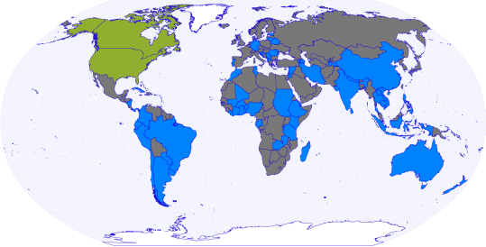 b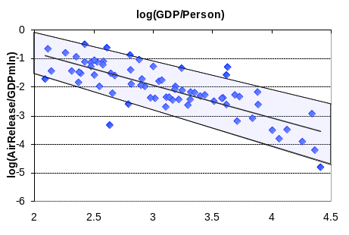
Fig. 2. Distribution of countries submitted their PCDD/F emission data to the SC (blue) and countries for which regression analysis (grey) and other data on emissions (green) were used (a) and regression relationship between annual PCDD/F releases of the countries and their Gross Domestic Product (b).
Further, confidence intervals at 80% level for coefficients A and B included in the equation (1) were calculated and applied for evaluation of PCDD/F emissions to air for various values of A and B and for estimation of the uncertainty of such emission evaluation. It was found that the total PCDD/F emissions to the atmosphere over the globe varied from 32 to 192 kg TEQ/y with average emission about 75 kg TEQ per year.
Anthropogenic emissions of PCDD/Fs to other media were estimated with the use of the data of the UNEP SC inventory, since it contained the estimates of PCDD/F releases to soil and water along with releases to the atmosphere. Emissions to soil and water for model calculations were obtained using the information on the relation between emission totals to these media taken from [Cao et al. 2013]. This relation strongly varied between countries. The paper presents relationships between emissions to air, soil and water separately for four groups of countries with different economic levels (low income or less, lower middle income, upper middle income, and high income or more). This information was used for generating emissions to all three above media in the emission scenario under construction. The values of total annual emissions to air, soil and water are displayed in Fig. 3. Due to relatively small amount of PCDD/Fs released to water bodies, this pathway of emission was not taken into account.
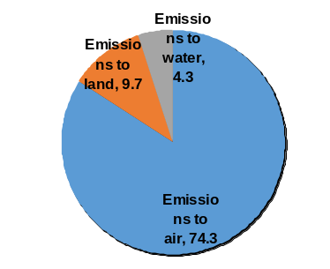
Fig. 3. Total emissions of PCDD/Fs to air, soil and water compartments according to the constructed scenario, kg TEQ/y.
Spatial distribution of PCDD/F emissions to air and soil on global scale with resolution 1°x1° was made on the basis of gridded data on population density. Obtained spatial distributions of annual emissions to these two environmental media are shown in Fig. 4. Relatively high levels of emissions are estimated for countries of Central Africa, Southern and Eastern Asia, and Europe. Low emissions are characteristic of North and South America, and Australia.
a 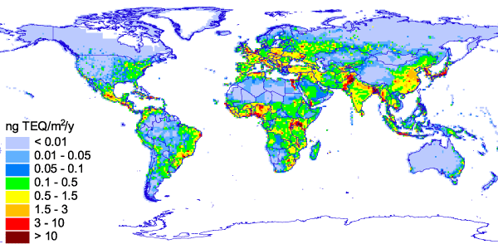 b 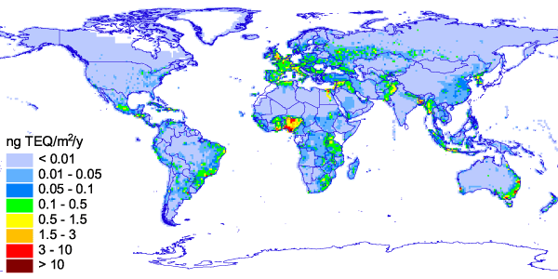
Fig. 4. Spatial distribution of annual PCDD/F emissions (ng TEQ/m²/y) to the atmosphere (a) and to soil (b) constructed on the basis of UNEP global PCDD/F emission inventory

The comparison of total PCDD/F emissions to the atmosphere according to the constructed scenario and to officially reported EMEP emission data is presented in Fig. 5.

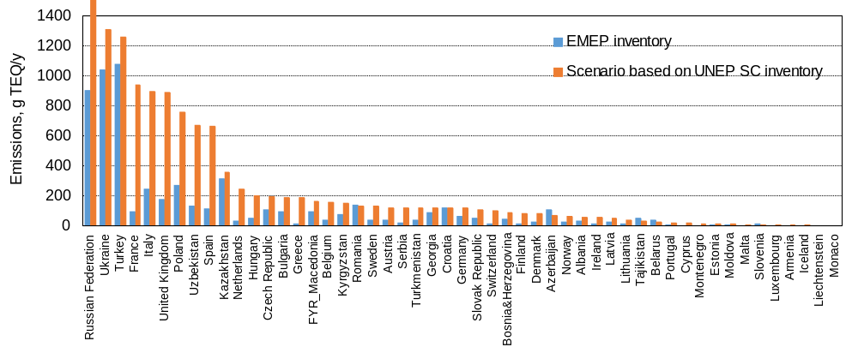
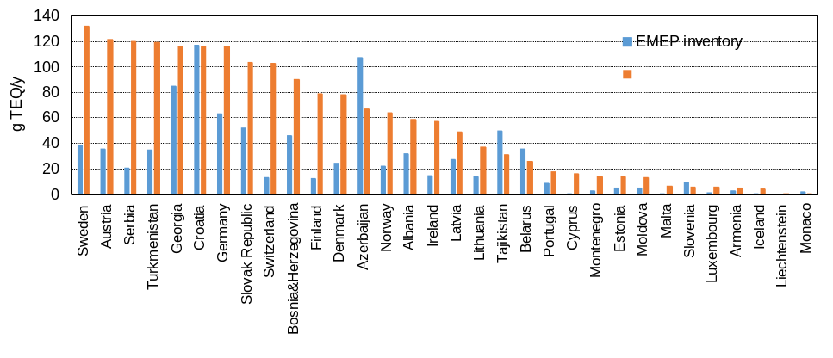
Fig. 5. Comparison of PCDD/F emission totals to the atmosphere according to the constructed scenario and to official EMEP emission data for 2005.
The comparison is presented for the year 2005 since the significant part of countries developed their inventories for the years around 2005. Total emissions of PCDD/Fs from the EMEP the countries according to the constructed scenario amounted to 14.5 kg TEQ/y, at the same time total emissions according to the data submitted to the LRTAP Convention were noticeably lower accounting for 6.3 kg TEQ/y.

Further progress in the developing of national inventories of PCDD/F emissions under the UNEP SC
There is substantial progress in the development of national inventories of PCDD/F releases to the environment by countries for the UNEP Stockholm Convention. According to the national reports, published at the UNEP SC web site in the beginning of 2016, the estimates of dioxins and furans emissions were available for more than 140 countries (http://chm.pops.int/Implementation/NIPs/NIPTransmission/tabid/253/Default.aspx). The reference years of the emission data varied from about 1998 up to 2014, at the same time most of the inventories were made for years around 2004. Substantial number of countries provided estimates of PCDD/F releases for several years that can be used for the evaluation of temporal changes of emissions.
Geographical distribution of national PCDD/F emissions to the atmosphere reported by countries to the UNEP SC is shown in Fig. 6. In accordance with submitted data the largest contributions to the global emission were made by Africa (36%) and South and East Asia (34%). The EMEP countries contributed 15% and contribution of North and South Americas is accounted for about 13%. It is seen that for some of the countries inventories of emissions were not available and thus actual contributions of particular regions might be somewhat different.

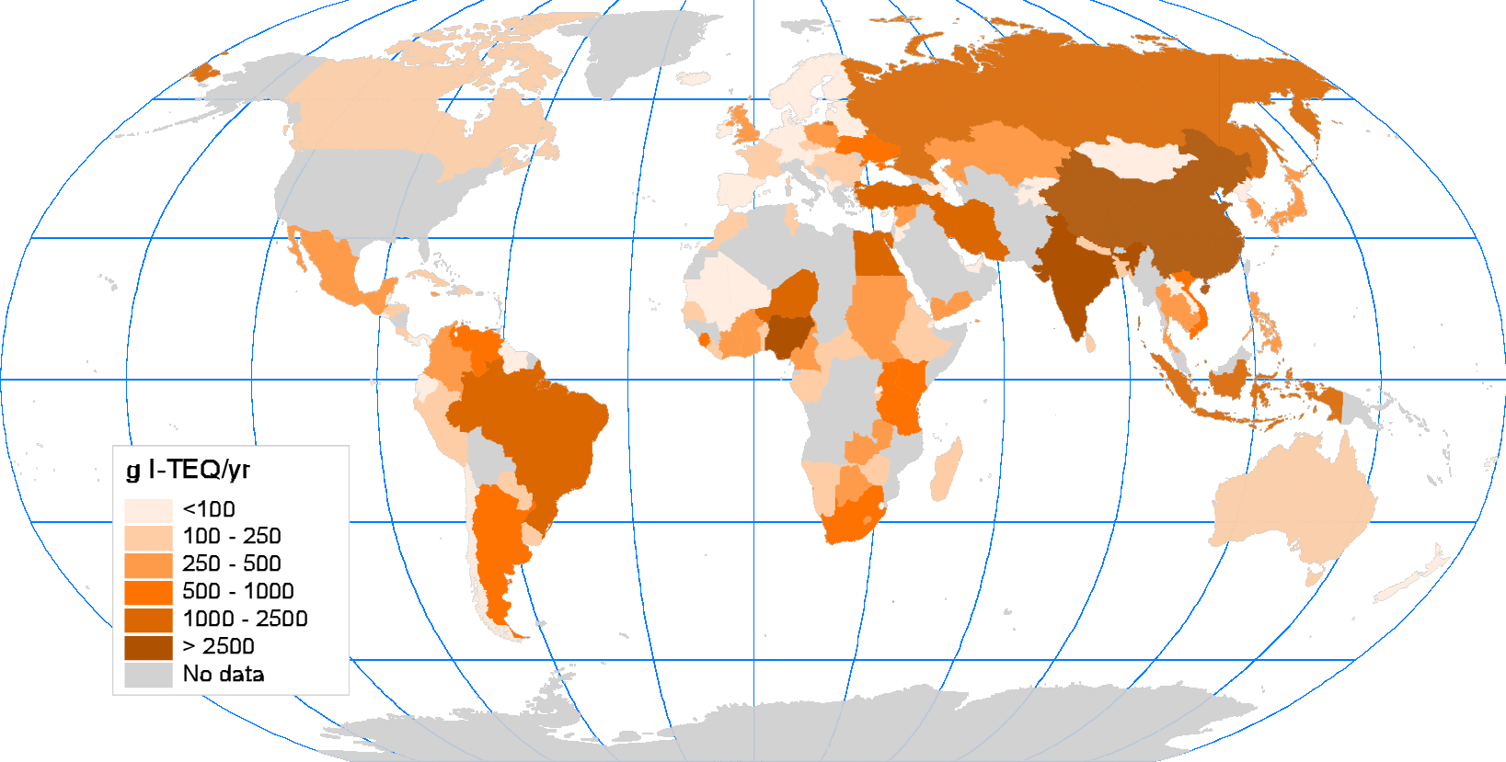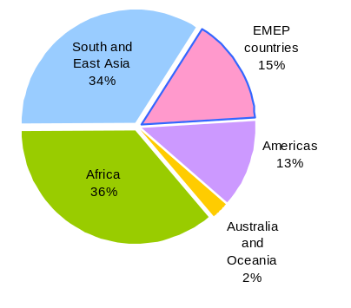
Fig. 6. Total releases of PCDD/Fs to the atmosphere from anthropogenic emission sources in different countries (g I-TEQ/yr) and contributions of major regions to global PCDD/F emission.
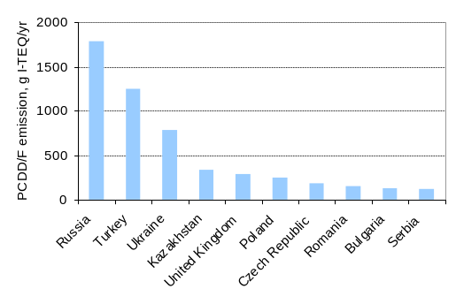
Fig. 7. Ten countries of the EMEP region with largest annual emissions of PCDD/F to the atmosphere, g I-TEQ/yr.
Within the EMEP region the most significant annual PCDD/F emissions from anthropogenic sources were reported by 10 countries including Russia, Turkey, Ukraine, Kazakhstan, the UK, Poland, Czech Republic, Romania, Bulgaria, and Serbia (Fig. 7). The share of emissions from these countries in total emission of the EMEP region exceeded 80%.
National inventories of PCDD/F releases provide important information on sector distribution of emission. In accordance with the data reported by countries the largest contribution to global emission is made by uncontrolled open burning processes (42%) followed by metal production (19%) and power generation/ heating (16%). At the same time data on emissions for the EMEP region demonstrate that major contribution is made by ferrous and non-ferrous metallurgy (37%) and power generation/heating (21%) while open burning contributes only 19%. These three source categories of releases comprise the largest contribution (more than 75%) to overall PCDD/F emissions to the atmosphere.
There is ongoing work in the Stockholm Convention on the refinement of national PCDD/F emission inventories, which includes the application of the most recent version of UNEP Standardized Toolkit and updates of national emission data [Black et al., 2012; Fiedler, 2015]. According to available requirements inventories of national releases need to be revised and updated every five year. Thus, the information reported by countries to the Stockholm Convention is of importance for further studies of environmental pollution by dioxins and furans as in the EMEP region and on the global scale and further co-operation between the LRTAP and Stockholm Conventions in this field is highly appreciable.

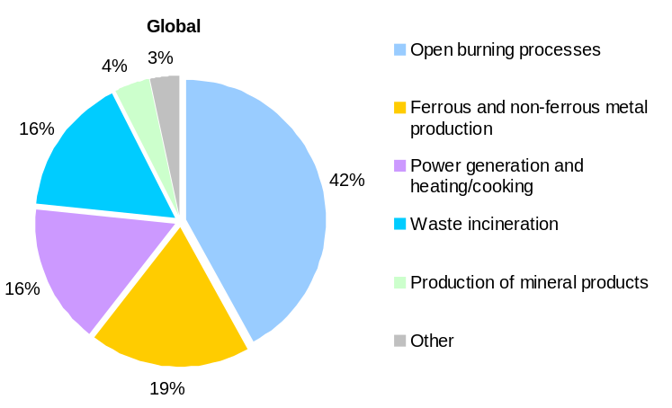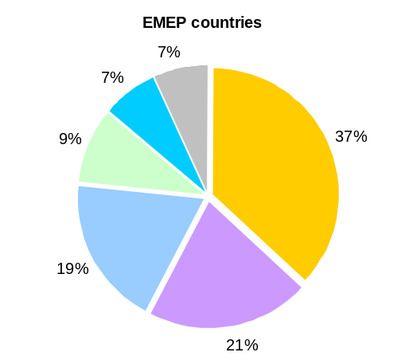
Fig. 8. Major source categories of PCDD/F emissions to the atmosphere for the EMEP countries and for the global scale emissions.

References
Cao Z., H. Fiedler, B. Wang, T. Zhang, G. Yu, J. Huang, S. Deng [2013] Economic status as a determinant of national PCDD/PCDF releases and implications for PCDD/PCDF reduction, Chemosphere 91, 328-335.
Black R.R., Meyer C.P., Touati A., Gullet B.K., Fiedler H., Mueller J.F. [2012] Emission factors for PCDD/PCDF and dl-PCB from open burning of biomass, Environment International, 38 (2012) 62–66.
Breivik K., R. Alcock, Y.-F.Li, R. E. Bailey, H. Fiedler, J.M. Pacyna [2004] Primary sources of selected POPs: regional and global scale emission inventories. Environmental Pollution 128, 3–1.
Fiedler H. [2015] Release Inventories of Polychlorinated Dibenzo-p-Dioxins and Polychlorinated Dibenzofurans. Dioxin and Related Compounds: Special Volume in Honor of Otto Hutzinger. M. Alaee (ed.). The Handbook of Environmental Chemistry (688), ISBN 978-3-319-23889-0, Springer, 2015.
Fiedler H. [2007] National PCDD/PCDF release inventories under the Stockholm Convention on Persistent Organic Pollutants, Chemosphere 67, S96–S108.
Fiedler H., Cao Z., Huang J., Wang B., Deng S., and Yu G. [2012] PCDD/PCDF inventories 1990 vs. 2012. Organohalogen Compounds, 74, 1521-1524.
Mareckova K., R. Wankmueller, R. Whiting, and M. Pinterits [2012] Inventory Review 2012. Technical Report 1/2012, CEIP, ISBN 978-3-99004-201-4.
Pacyna J.M. et al. [1999] Final report for Project POPCYCLING-Baltic. EU DGXII, Environment and Climate Program ENV4-CT96-0214. Available on CD-rom including technical report, the emission and environmental databases as well as the POPCYCLING-Baltic model. NILU, P.O. Box 100, N-2027 Kjeller, Norway.
Shatalov V., J. H. Johansson, K. Wiberg, I. T. Cousins [2012a] Tracing the origin of dioxins in Baltic air using an atmospheric modeling approach. Atmospheric Pollution Research, 3, pp. 408–416
Shatalov V., Ilyin I., Gusev A., Rozovskaya O., Sokovykh V., Travnikov O., Wiberg K. and Cousins I. [2012b] Heavy Metals and Persistent Organic Pollutants : New developments. EMEP/MSC-E Technical report 4/2012.
Shatalov V., Ilyin I., Gusev A., Rozovskaya O., Travnikov O. [2014] Heavy Metals and Persistent Organic Pollutants: Model Assessment of Pollution and Research Activities. EMEP/MSC-E Technical report 4/2014.
UNEP, 2013 Technical Background Report for the Global Mercury Assessment 2013. Arctic Monitoring and Assessment Programme, Oslo, Norway/UNEP Chemicals Branch, Geneva, Switzerland. vi + 263 pp.
Vulykh N. and V.Shatalov [2001] Investigation of Dioxin/Furan Composition in Emissions and in Environmental Media. Selection of Congeners for Modelling. MSC-E Technical Note 6/2001.
Wiberg K., A. T. Assefa, K. L. Sundqvist, I. T. Cousins, J. Johansson, M. S. Mc Lachlan, A. Sobek, G. Cornelissen, A. Miller, J. Hedman, A. Bignert, H. Peltonen, M. Kiljunen, V. Shatalov and I. Cato. [2013] Managing the dioxin problem in the Baltic region with focus on sources to air and fish. Report 6566, Swedish Environmental Protection Agency.
Annex II
EMISSION DATA FOR MODEL ASSESSMENT (POP STATUS 3/2010)
HCB emissions
Hexachlorobenzene is highly persistent toxic chemical which was widely used as fungicide from the beginning of 1940s. After restrictions and banning of HCB usage as a fungicide/pesticide in many countries starting from 1970s its atmospheric concentrations significantly declined. However it is still released to the environment in course of manufacturing of various chlorinated compounds as unintentional by-product. Content of HCB in the atmosphere during the two recent decades is largely controlled by secondary emissions from the environmental media previously polluted due to agricultural or industrial activities, while relative contribution of anthropogenic emissions is rather small [Barber et al., 2005].
Importance of secondary HCB emissions was considered in several previous studies performed by MSC-E [Shatalov et al., 2010; Gusev et al., 2011]. It was concluded that further improvement of the evaluation of HCB pollution levels in the EMEP countries could be achieved by the refinement of historical releases of HCB to the environment as well as officially reported HCB emissions. As noted in [Mareckova et al., 2012] anthropogenic HCB emissions reported by the EMEP countries are subject of uncertainties and their estimates require further refinement with regard to spatial and temporal coverage and completeness of information on its releases from various source categories.
Due to its high persistence in the environment long-term accumulation of HCB in environmental media (soil, seawater) substantially influences HCB contamination levels. Thus, for the evaluation of HCB pollution levels historical emissions for sufficiently long period of time should be used. There is a lack of global inventories of HCB emissions to the atmosphere and other media. Therefore, to evaluate global distribution and fate of HCB, three experimental scenarios of historical global HCB emissions were constructed for modelling of long-term accumulation of the pollutant in the environmental media using the approach described in [Shatalov et al,. 2010].
Following available information the application of HCB in various activities was started from 1945 and reached its maximum in 1980-s. The major source of its release into the environment in that period was the application in the agriculture as a fungicide. Additional sources contributing to the emissions of HCB were the production of chlorinated solvents and pesticides, wastes and sewage sludge incineration, metals smelting, sintering process, steel manufacturing, production of magnesium and cement as well as combustion of fossil fuel. Following the information on agricultural use of HCB in [Food and Agriculture Production Yearbook, 1989] Vulykh and Putilina [2000] estimated that the global HCB emissions in 1980-s could ranged approximately from 7 kt to 18 kt per year with average annual emission about 12 kt. It should be noted that these estimates are subject of essential uncertainties as they do not cover all the countries where the HCB was applied.
Starting from 1980-s the agricultural use of HCB was banned in many countries world-wide resulting in substantial decrease of HCB use and emissions. According to the estimates of Bailey et al. [2001] annual global emissions of HCB in the middle of 1990-s were about 23 t per year varying in the range from 12 t to 92 t. Using these estimates three simple scenarios (maximum, average, and minimum) of global HCB emission temporal development in period 1945-2013 were elaborated. For two recent decades it was assumed that global emissions were gradually decreasing by about 10% a year on average. Temporal variation of global HCB emission according to maximum scenario is shown in Fig. 4.3a. Spatial distribution of global emission was prepared with the spatial resolution 11 degree using the distribution of cropland area [Li, 1999] for the emissions from agricultural use and population density [Li, 1996] for other sources of HCB emissions (Fig. 1).
a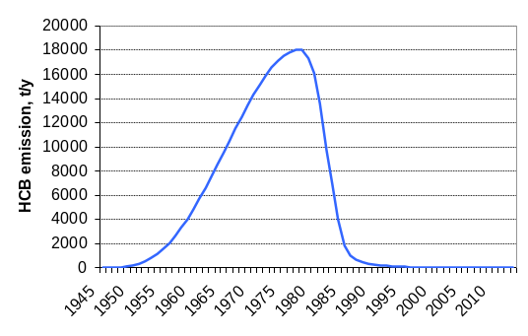 | 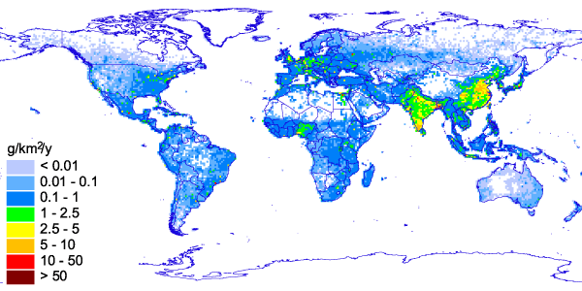  b
Fig. 1. Scenario of temporal variations of global emission of HCB to the atmosphere in the period 1945-2012 (a) and spatial distribution of HCB emissions to the atmosphere for 2013 over global domain with resolution 1⁰x1⁰ (b)
Model simulations with the constructed scenarios of HCB emission permitted to evaluate HCB fate in main environmental compartments in line with other modelling studies. In particular, it was indicated that for contemporary period of time major part of HCB mass in media was stored in soil (more than 90%), while other media contained only small share of the total environmental burden. These estimates of HCB distribution in the environment were close to modelling studies of HCB fate of [Zhang et al., 2003], [MacLeod and Mackay, 1999], and [Barber et al., 2005].
Elaboration of scenarios of historic and current HCB emissions resulted in reasonable agreement of modelling results with available measurements and demonstrated essential role of the historic emissions for the evaluation of HCB pollution levels [Shatalov et al., 2010; Gusev et al., 2011; Shatalov et al., 2015]. Further investigations of HCB long-range transport and fate in the EMEP region and on global scale requires further refinement of officially reported emission data of the EMEP countries and elaboration of global gridded emission inventories.
References
Bailey R.E. [2001] Global hexachlorobenzene emissions. Chemosphere, vol. 43, pp. 167-182.
Barber J. L., Sweetman A., van Wijk D., Jones K. C., [2005], Hexachlorobenzene in the global environment Emissions, levels, distribution, trends, and processes, Science of the Total Environment, 349, 2005, 1-44
Food and Agriculture Production Yearbook [1989] Food and Agriculture Organization of the United Nations (FAO), Rome, 43, 318.
Gusev A., S.Dutchak, O.Rozovskaya, V.Shatalov, V.Sokovykh, N.Vulykh, W. Aas, K. Breivik [2011] Persistent Organic Pollutants in the Environment, EMEP Status Report 3/2011.
Li Y.-F. [1996] Global Population Distribution Database, A Report to the United Nations Environment Programme, under UNEP Sub-Project FP/1205-95-12, March 1996.
Li Y.F. [1999] Global gridded technical hexachlorocyclohexane usage inventory using a global cropland as a surrogate, J. Geophys. Res., vol 104, pp. 23785-23797.
MacLeod M. and D. Mackay [1999]. An assessment of the environmental fate and exposure of benzene and the chlorobenzenes in Canada. Chemosphere, vol.38, pp.1777–96.
Mareckova K., R. Wankmueller, R. Whiting, and M. Pinterits [2012] Inventory Review 2012, Technical Report 1/2012, CEIP, ISBN 978-3-99004-201-4.
Shatalov V., A. Gusev, S. Dutchak, O. Rozovskaya, V. Sokovykh, N. Vulykh, W. Aas, K. Breivik [2010] Persistent Organic Pollutants in the Environment. EMEP Status Report 3/2010.
Shatalov V., Ilyin I., Gusev A., Rozovskaya O., Travnikov O. [2015] Heavy Metals and Persistent Organic Pollutants: development of multi-scale modeling and trend analysis methodology. EMEP/MSC-E Technical report 1/2015.
Vulykh N. and V.Putilina [2000] Hexachlorbenzene. Properties, Emissions and Content in the Environment. MSC-E Technical Note 6/2000.
Zhang Q., J.C. Crittenden, D. Shonnard, J.R. Mihelcic [2003] Development and evaluation of an environmental multimedia fate model CHEMGL for the Great Lakes region. Chemosphere, vol. 30, pp. 1377-1397.
Annex III
EMISSION DATA FOR MODEL ASSESSMENT (POP STATUS 3/2012)
Temporal variations of B[a]P emissions
To evaluate seasonal variations of B[a]P pollution levels temporal variations of its emissions from three main source categories (residential heating, industrial processes and road transport) were introduced into the model.
To construct temporal variability of emissions one should take into account that this variability depends on the type of emission source (emission source category). So, prior to modelling this variability, the contributions of various emission source categories to the overall B[a]P emissions should be assessed. According to the official emission data for 2010 complemented by the data from TNO emission inventory when necessary, main contribution to the emissions is made by residential heating (about 50%), followed by road transport (30%), industrial processes (11%) and waste incineration (3%). The contribution of the rest emission source categories is accounted for about 5%. Main source categories of B[a]P emissions are shown in Fig. 1.
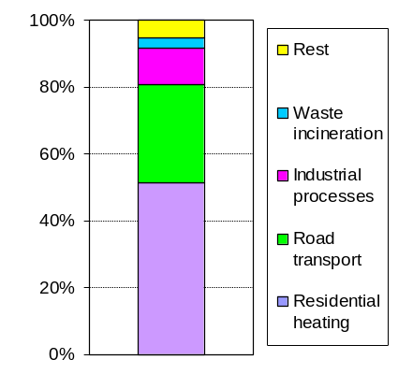
Fig. 1. Main source categories
of B[a]P emissions
The approach to estimate temporal variations of B[a]P releases from residential heating source category, based on the data on the dependence of power supply on ambient air temperature, was worked out by [Aulinger et al., 2010]. This approach was tested using the data on power supply dynamics during 2005 – 2006 in Hamburg, Germany. In J.Beecken [2007] it is shown that the quantity of heat that is supplied to consumers linearly decreases with the increase of the ambient temperature up to 18º C where the supplied heat reaches a minimum and remains constant for higher temperatures. Under the assumption that B[a]P emissions are directly proportional to the supplied heat, it can be concluded that B[a]P emissions drop linearly with the temperature increase up to 18º C and remain constant at higher temperatures. On the basis of this assumption, the dependence of B[a]P emissions on temperature is calculated and distributed over the year for each grid cell according to the ambient air temperature in such a way that redistribution does not change total annual emissions.
It should be stressed that the parameters of temperature dependence of emissions can be different for different regions of the EMEP domain. Parameters of temperature dependence of emissions can also vary depending on the implemented technology of power supply. Sensitivity of seasonal variations of emissions to the parameters of temperature dependence is investigated in [Aulinger et al., 2010]. It is shown that the usage of temperature-dependent emission variations improves the agreement between measurements and model predictions.
Former parameterization of seasonal changes of B[a]P emission to the atmosphere, applied in the MSCE-POP model, assumed the scaling factors for autumn and winter months (1.2) and for summer and spring months (0.8) following the estimates of [Baart et al., 1995]. Comparison of modified and earlier used intra-annual variations of B[a]P emission for the particular location in Central Europe is given in Fig. 2.
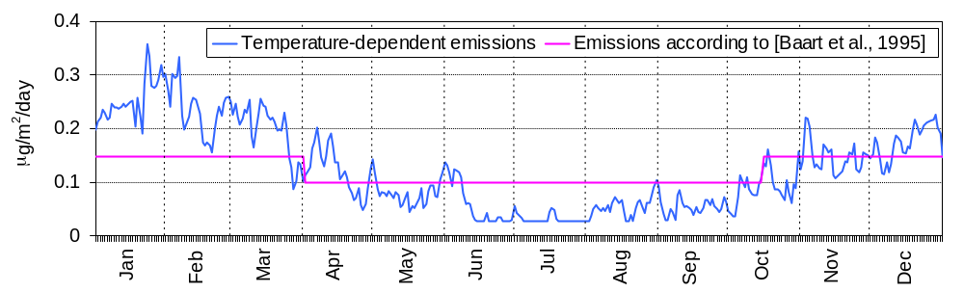
Fig. 2. Temporal variations of B[a]P emissions at a particular location in Central Europe.

It is seen that usage of temperature dependent scheme of emission seasonal variations leads to significantly higher emissions (by 45% on the average) in cold season (from December to March) and lower emissions (by 50% on the average) in warm season (from June to September). In April, May and October temperature-dependent emissions are oscillating around the values predicted by the estimates of [Baart et al., 1995].
Temporal variations of emissions for road transport and industrial processes categories are constructed in accordance to the coefficients used in LOTOS/EUROS model [Schaap et al., 2005]. Seasonal variations of these emissions are illustrated in Figs. 3a and 4a, where fractions of annual emissions for each month are shown. Besides, variations of emissions within a week are taken into account (Figs. 3b and 4b). Emissions of all other source categories are supposed to be constant over the year.
a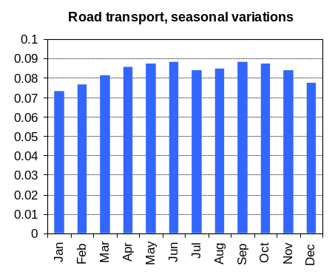 b 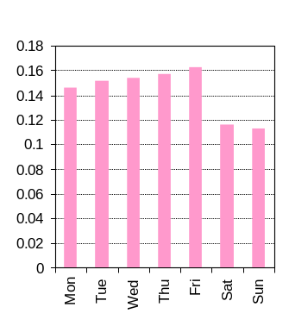
Fig. 3. Monthly fractions of annual emissions (a) and daily fractions of weekly emissions (b) for emissions from road transport.

a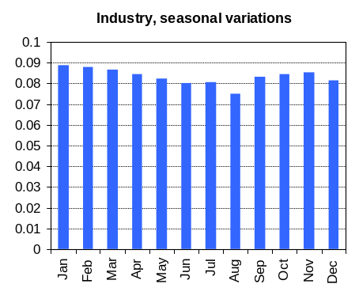 b 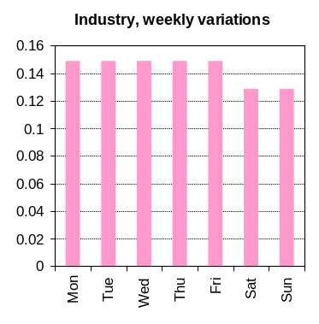
Fig. 4. Monthly fractions of annual emissions (a) and daily fractions of weekly emissions (b)
for emissions from industrial sources.
The diagrams demonstrate that the supposed seasonal variations of emissions from industrial sources and road transport are low enough in comparison with those used for the emissions from residential heating.
Influence of emission seasonal variations
For evaluation of the influence of seasonal variations of emissions (SV), model simulations for 2009 using previous and modified seasonal variations are carried out.
The comparison of model simulations of B[a]P long-range transport taking into account temperature dependence of emissions (modified SV) with calculations using coefficients proposed by [Baart et al., 1995] (previous SV) allows evaluating the influence of this dependence on B[a]P concentration levels. Table 1 provides evaluation of temporal correlation between the measurements made at the EMEP monitoring sites and model predictions based on these two calculation schemes of emissions seasonal variations.

Table 1. Correlation coefficients between measurements and model results based on previous seasonal variations scheme (previous SV) and modified one (modified SV) for some EMEP measurement sites.
 | BE13 | CZ3 | DE1 | DE9 | NO42 | SI8
Previous SV | 0.91 | 0.77 | 0.71 | 0.87 | 0.42 | 0.89
Modified SV | 0.94 | 0.82 | 0.72 | 0.83 | 0.47 | 0.97

The comparison shows that almost for all measurement sites correlation between measured and calculated concentrations enlarges due to implementation of temperature dependence of B[a]P emissions. The comparison of the results of these two simulation schemes with measurements at CZ3 (where correlation coefficient becomes better) and DE9 (where correlation coefficient becomes worse) is given in Fig. 5.

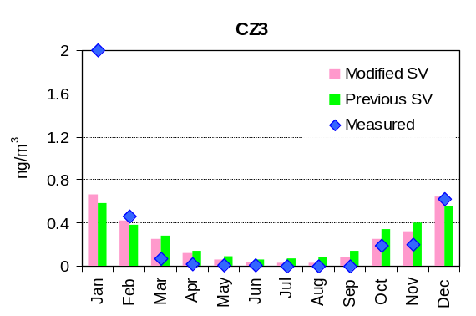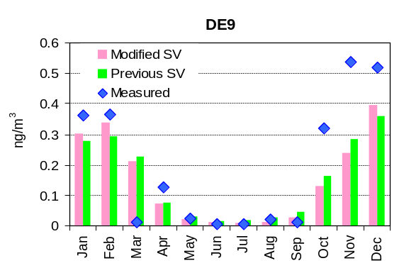
Fig. 5. Comparison of measured values of B[a]P concentrations at CZ3 and DE9 with calculation
results using previous and modified scheme of emission seasonal variations.

It is seen that some improvement of the agreement between measurements and model predictions takes place at CZ3. At the site DE9 in some cases the agreement becomes even worse. This shows that temporal variations of emissions may depend on a particular country.
The improvement of the agreement for warm season is considered separately. For example, at BE13 measurement-to-calculation ratio for air concentrations in warm months has risen from 0.38 to 0.61, at DE1 – from 0.22 to 0.41 and at DE9 – from 0.42 to 0.79 (see Fig. 6).
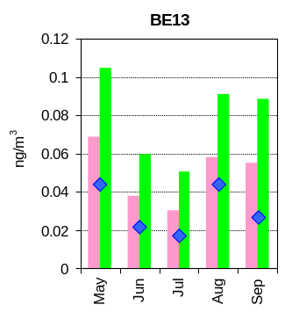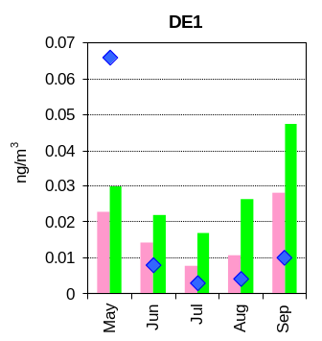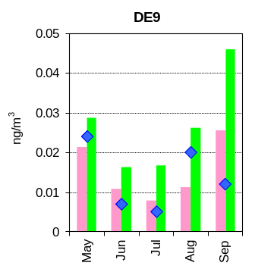
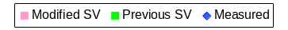
Fig. 6. Comparison of measured values of B[a]P air concentrations with calculated ones for previous
and modified emission seasonal variations for the period from June to September at three EMEP sites.
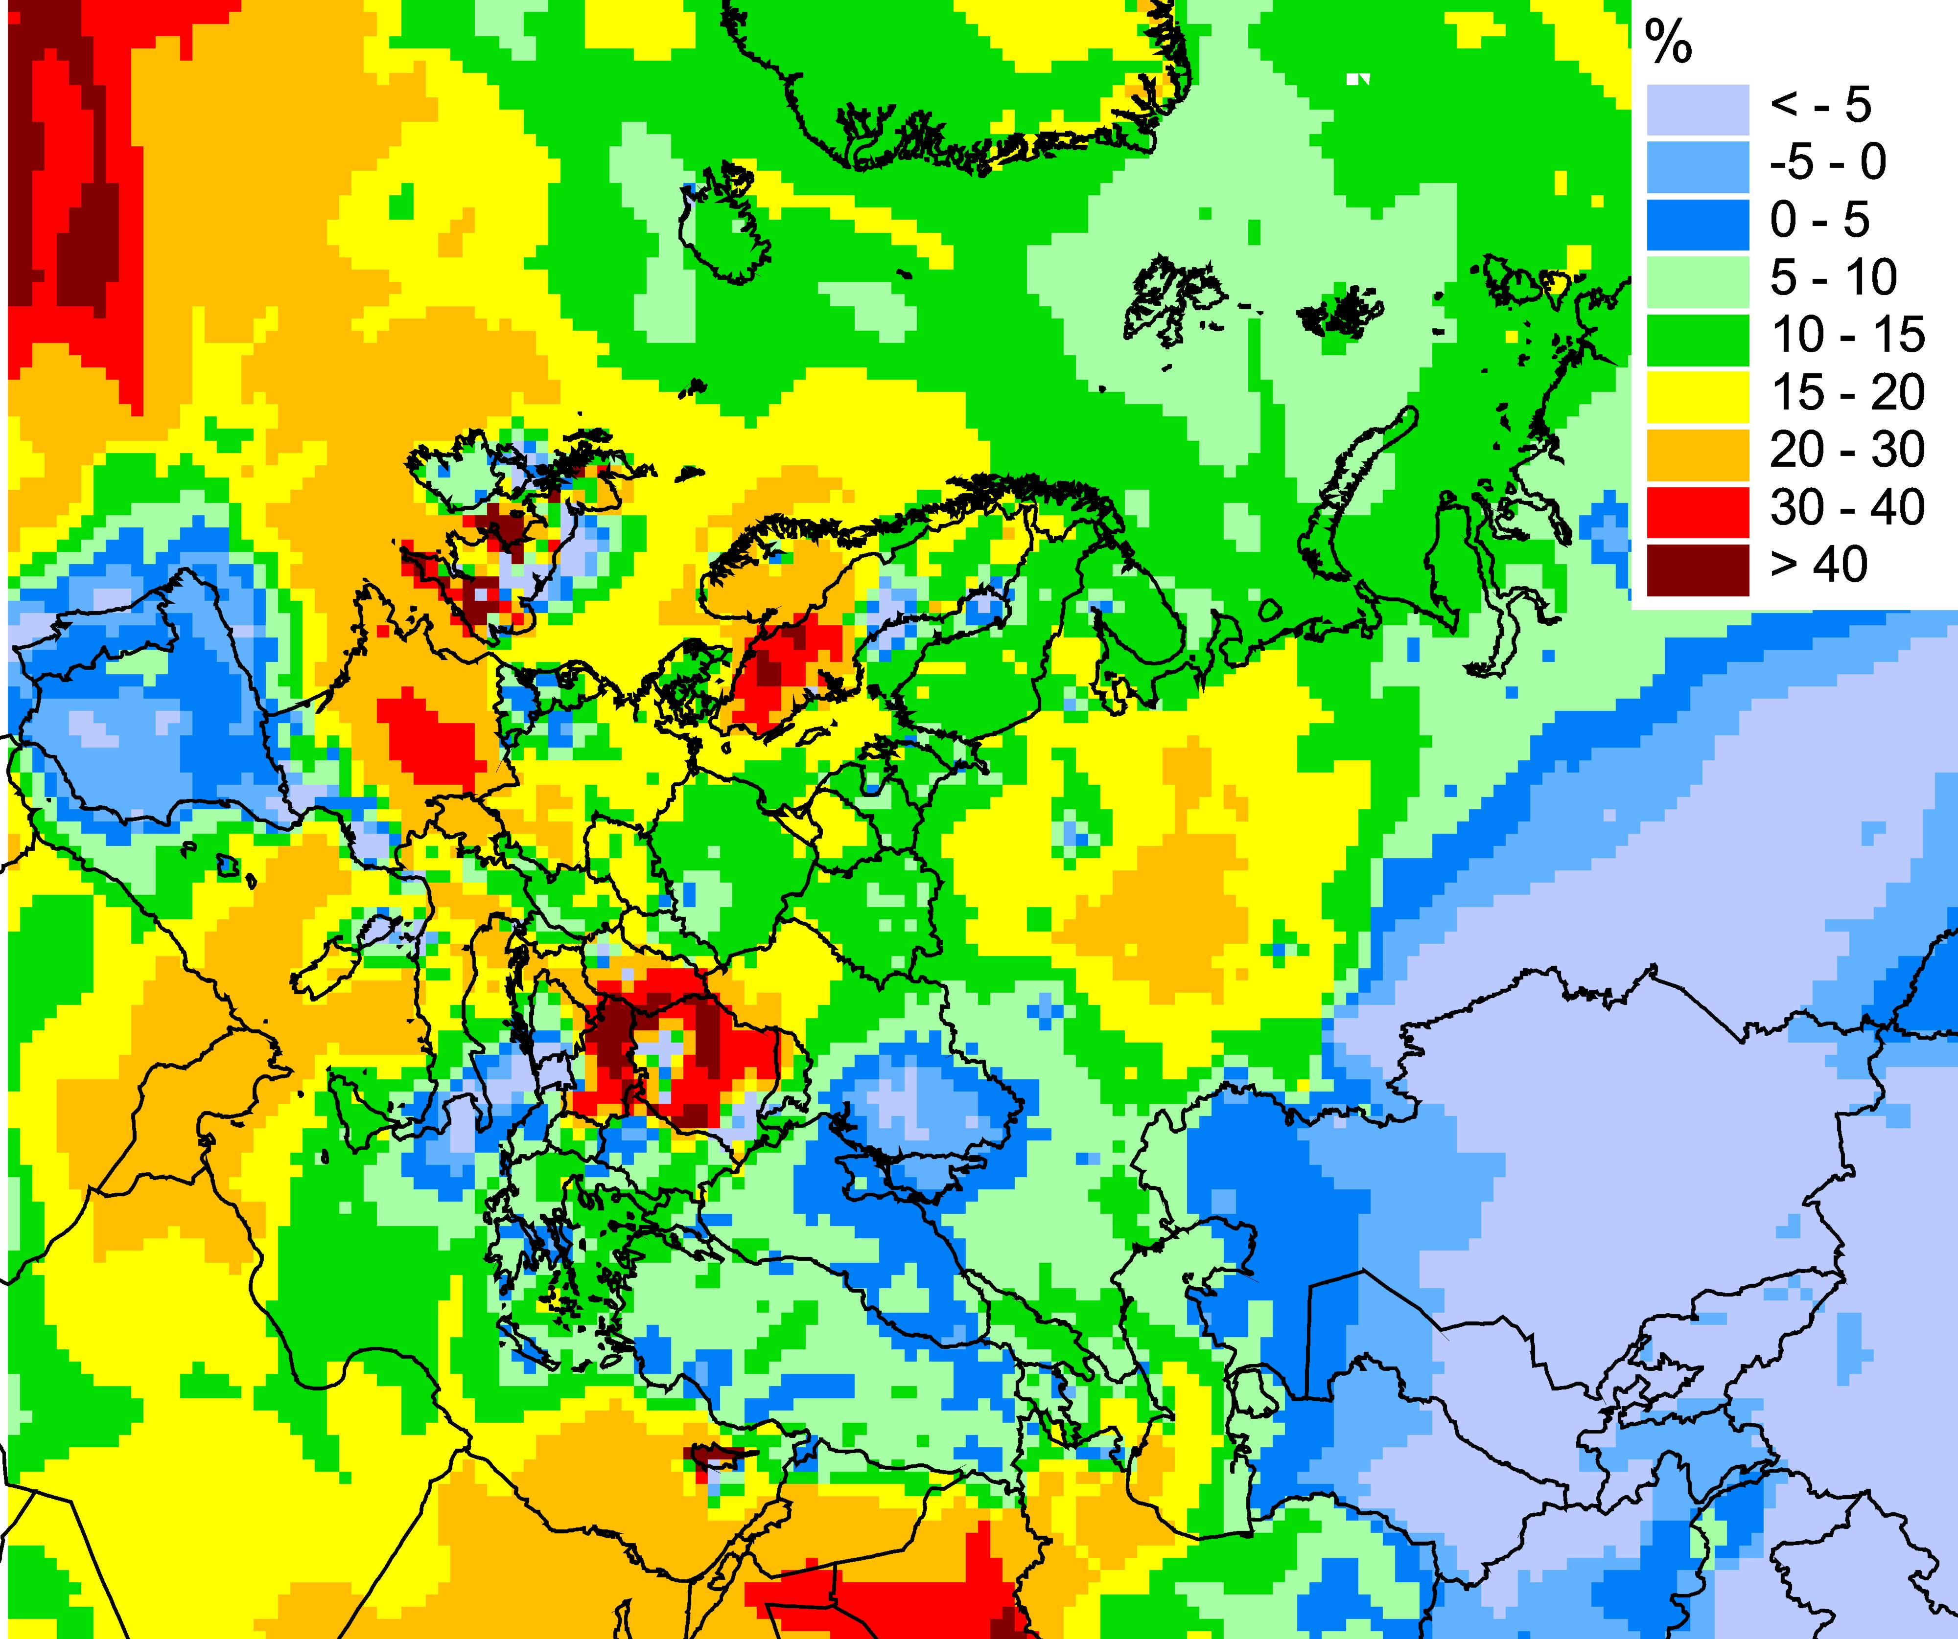
Fig. 7. Difference between calculations with previous and modified schemes of emission seasonal variations.
In most of the cases model calculations using modified seasonal variations of emissions better agree with measurements than calculations made with the use of previous emission seasonal variations. However, the agreement is improved differently for sites located in different regions.
It is interesting also to evaluate the difference between annual averages of B[a]P air concentrations calculated with previous and modified emission seasonal variations over the whole EMEP grid. Spatial distribution of this difference is shown in Fig. 7.
Temporal variability of B[a]P emissions can considerably (up to 40% and higher) affect annual means of air concentrations. This variability strongly depends on emission composition from the viewpoint of source categories.
Thus, information on intra-annual variations of emissions from various source categories is an important factor for correct assessment of B[a]P contamination levels.

References
Aulinger A., V. Matthias and M. Quante [2010]. An Approach to Temporally Disaggregate Benzo(a)pyrene Emissions and Their Application to a 3D Eulerian Atmospheric Chemistry Transport Model, Water, Air, & Soil Pollution, vol. 216, No. 1-4, pp. 643-655.
Baart A., Berdowski J., van Jaarsveld J. and K. Wulffraat [1995] Calculation of atmospheric deposition of contaminants on the North Sea. TNO-MEP-R 95/138, Delft, The Netherlands.
Beecken J. [2007] Pilotprojekt KWK-Optimierung, Teilbericht des Netzes des Forschungsprojektes KWK-Optimierung. Tech. rep., Vattenfall Hamburg.
Schaap M., M. Roemer, F. Sauter, G. Boersen, R. Timmermans, and P. G. H. Builtjes [2005] LOTOS-EUROS: documentation, TNO report B&O-A R 2005/297.

